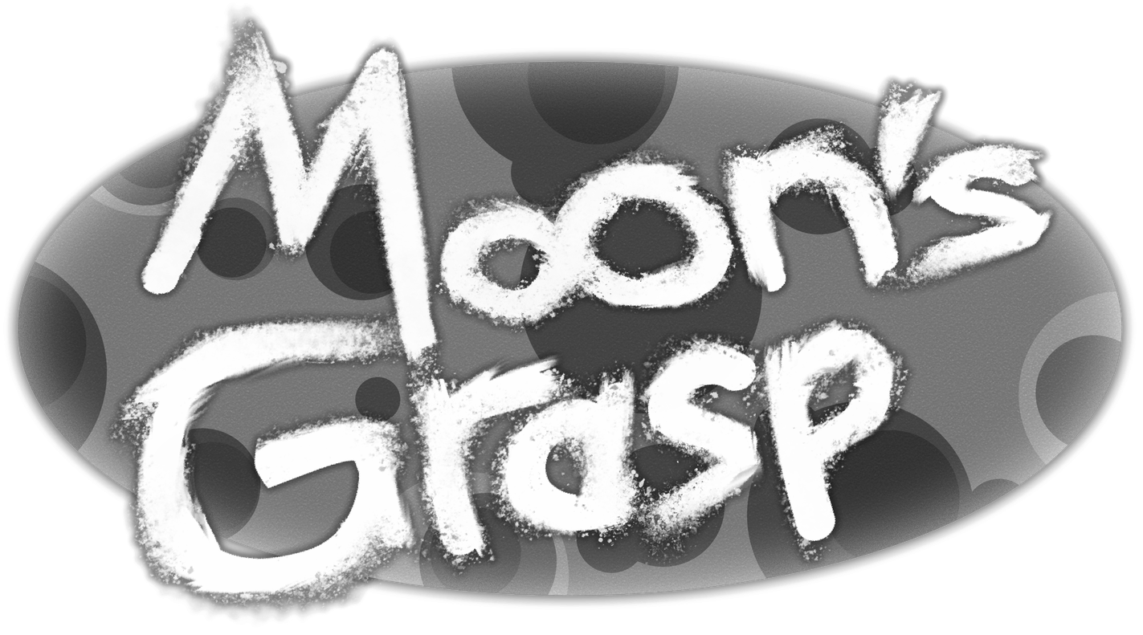

Abstract

In this Document I will be describing the Web Game we have decided to create called Moon’s Grasp

Game Design Document

Andrew Scott (B00372962) Programmer

Tembani Mdaya() Artist

Contents

Game plan 2

Game Overview 2

Risk Analysis 2

Game Design 2

Game Concept 2

Gameplay 3

Game Interface Design 3

Game Environment/ Level Design 4

Game Implementation 4

Game Features 4

Gameplay & Player Mechanics 4

References 5

# Game plan

## Game Overview

The Game we are planning to create is a side scrolling, level-based 2.5D platformer called Moon’s Grasp. The game will be set on the Moon where an alien presence has been discovered that then attacks from below the moon’s surface, the player must get back to their moon base while contending with low Oxygen and the alien threat eventually making it to the central moon base to escape. The game will be developed for PC using Unity.

## Risk Analysis

Some of the Risks involved and that will possibly be encountered during the development of this game are as such:

* Hardware issues – unforeseen hardware brakes, such as parts of the Desktop malfunctioning make it a bit inconvenient to make the game. Thankfully its uncommon for it to happen but not something to be discounted.
* Software issues – Software glitches and save corruptions are a major threat when it come to game design with no way to predict them. The best way to prevent them is to save often and have a few different save areas, one of the ones out team is using is Git Hub.
* Over Admission – Trying to do too much, trying to put all the Ideas you have for a game into it usually means it will never be done. Try to get the main concept in first and add to them IF there is time.
* Health Issues – given current situations its reasonable that some of us aren’t going to be in good enough health to be able to work on the game all the time. Best we can do is get done what we can and let others know when we can’t so it can be picked up by someone that can.
* Lack of Time management – these ties into “over ambition”, trying to do too much without the time to do it, but it’s also partly not getting done what needs to be done in a timely manner.

# Game Design

## Game Concept

The game is inspired by a few gameplay concepts from some games released recently as well as some that have been around for some time. We decided to make the game a 2.5D platformer as the genre has been making a resurgence lately with games such as Ori and the Will of the Wisps, Spelunky 2 and Super Meat Boy Forever to name a few popular ones, all of which have been received well and had a good amount of success.

The concept for the Oxygen management came from a moon exploration game called “Deliver Us The Moon”. The game was more investigation/exploration centred with some small platforming challenges along the way but most of the games challenge comes from managing the players oxygen supply and finding canisters to resupply it.

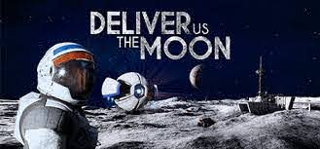 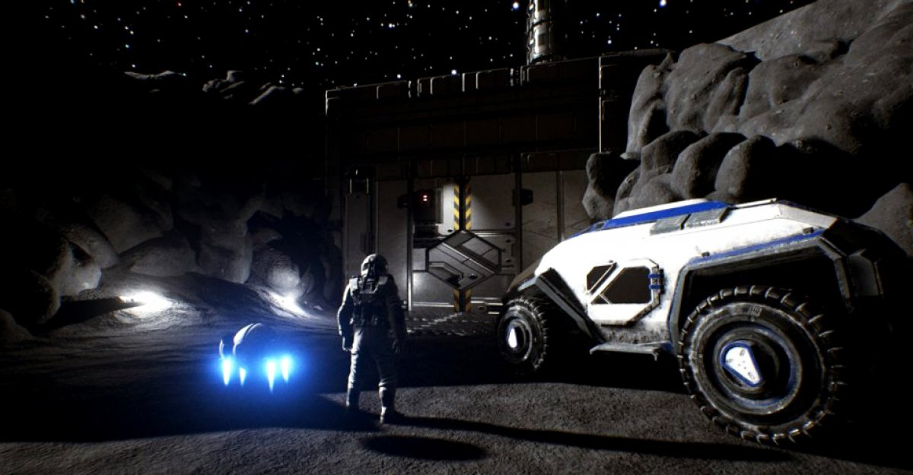

One of the more obvious insperations is Mario for the 2D platforming and planed enemy placments along with how the level structure/ progression.

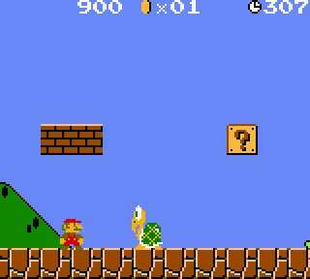 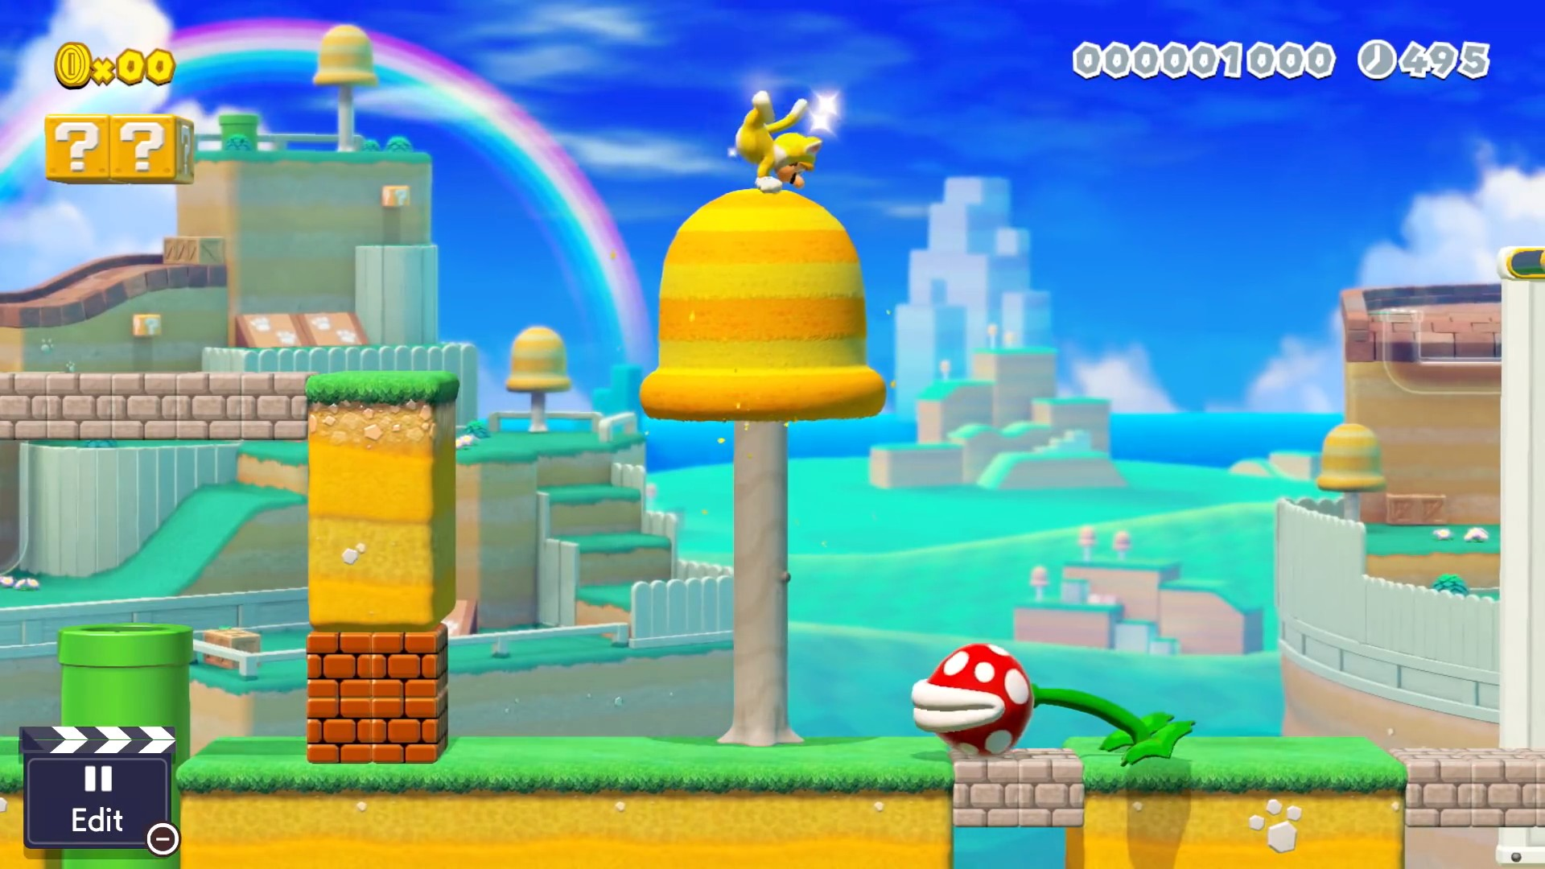

For the depleating resource that keeps the player alive and finding a container or something similer during the level concept, an old moble game called “Hill Climb Racing” was the insperation for it. The player tries to get as far as they can while they lose fuel and have to pick up contaners to refuel, if the don’t get to one in time they get a game over.

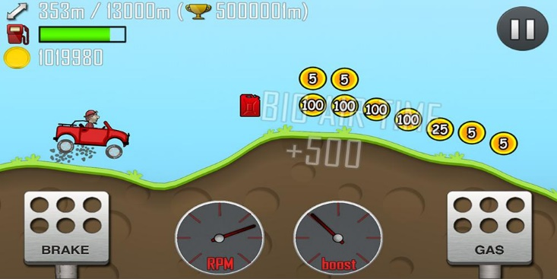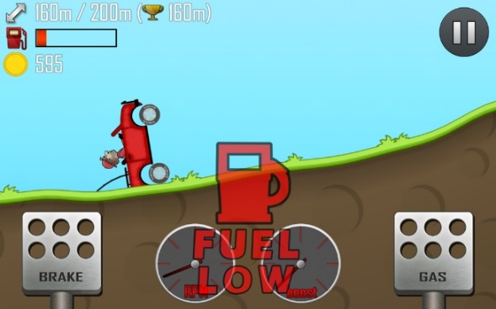

## Gameplay

The gameplay of Moon’s Grasp will consist of the player trying to make their way through platforming levels of increasing difficulty while trying to avoid alien enemies and manage their O2 levels with the main goal of the player being to reach individual moon base’s for safety, eventually making it to the master moon base to escape the Moon’s Grasp. The structure of the game is rather linier as we have no intention to put branching paths or secret shortcuts into the game however that may change if we have time to implement it.

## Game Interface Design

For the start menu of the game the UI will be ferly simple with a Start and Quit button as well as a controls button to show the player how to control their character in game. The in-game UI will be rather minimalistic having the timer for the players oxygen and their health at the top of the screen like “Hill Climb Racing” or on the player character similar to Isaac from “Dead Space”, we will decide closer to implementation. As the players oxygen gets lower it will slowly start turning red, eventually showing a warning indicator.

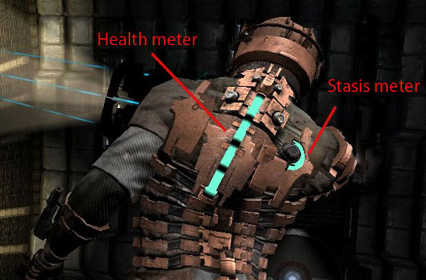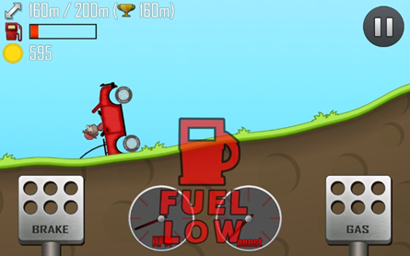

## Game Environment/ Level Design

Given the game is set on the moon it will mostly be space/moon colonist themed mixed with the desolate emptiness of the moon. As the player progresses through the game more and more of the moon and colonist buildings will get covered with alien biology and structures showing their spread. The of the inspirations for this concept come from “Red Faction Armageddon” and “Dead Space”, the alien’s rising from underground and the colonist structures are inspired from “Red Faction Armageddon” and the alien biology taking over buildings is inspired by “Dead Space”, both having the theme of colonisation as well as alien terror.

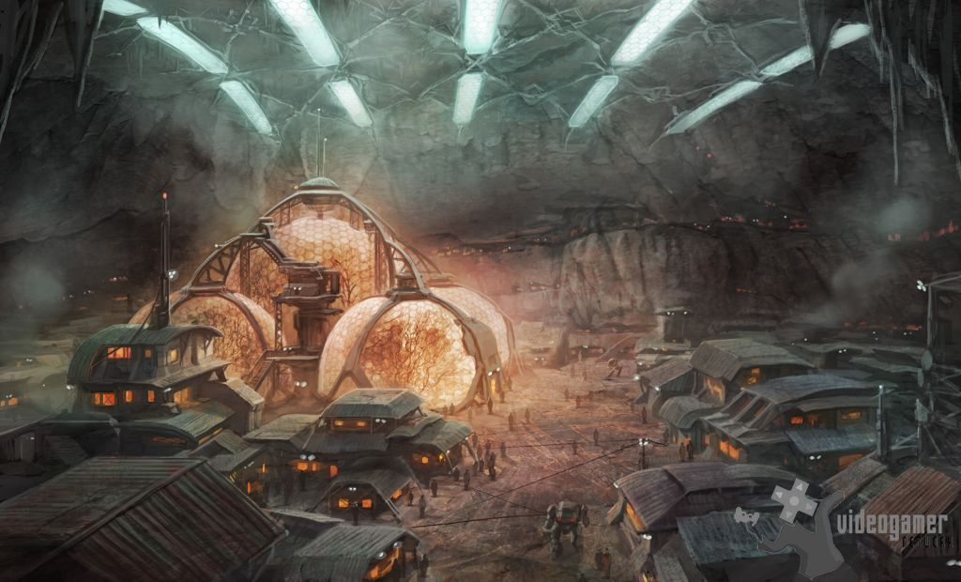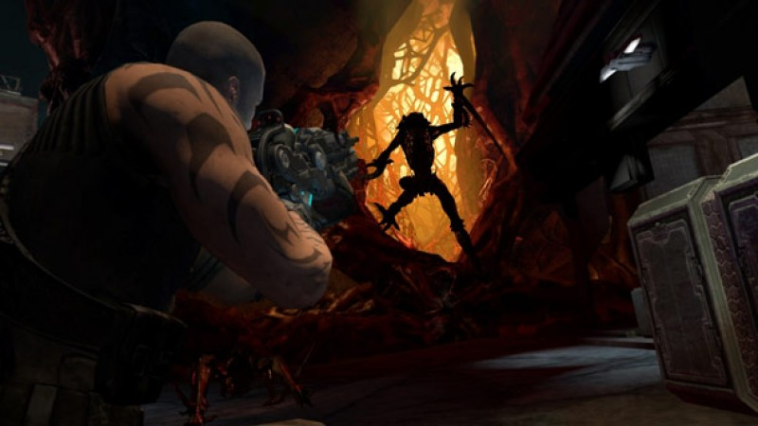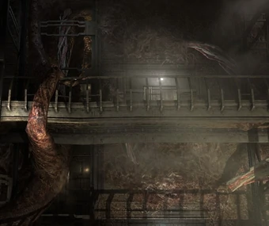

# Game Implementation

## Game Features

The main feature of the game is the Oxygen meter, the obvious reason it is there if to show the player their oxygen level and worn them when its low but there are 2 other mechanics tied into it, a jet pack style double jump and a dash that ill go into more detail in “Player mechanics”. One of the other features are the Aliens, they are not anything special for a platformer as they patrol an area and if the player hits them they do damage however if the player lands in the area they patrol they will start to chase them till they leave tat area. An idea that will be implemented if there is time is a special Alien that that follows the player from stage to stage chasing them down and meaning they cant linger in one spot for too long like “Mr X” or the “Nemesis” from the recent “Resident Evil” remakes.

## Gameplay & Player Mechanics

As mentioned in the previous section the Oxygen meter plays an important part in the players control and movement as it both keeps the player alive but also is used as the fuel for their double jump/jet pack and their dash ability’s. Playing through the levels if the player dose not use any of the abilities they will have enough Oxygen to make it to the next refill tank with enough oxygen to make a good number of mistakes on the platforming challenges though it will make them more difficult as well as make them slower, giving the chaser Alien more of a chance to catch them, however if they choose to use the abilities it will make the chances of the Alien caching them low and make the platforming easier but they will barely have the time to reach a refill canister giving a risk and reward to their usage.

## References

[GitHub (version control)](https://github.com/tj3k/Group_X-Moons-Grasp-Project)

[Youtube (Game Mechanics Showcase)](https://www.youtube.com/channel/UCfUvS74GyahRgr33et83oDw/)